State Supervision Requirements for SLPAs and Cooperating Clinicians

FOR SLPAs

1. All SLPAs upon being hired by an organization are required to set up an account in the Pennsylvania Licensing System (PALS)
Website: www.pals.pa.gov
- Follow the steps to register for a new account:

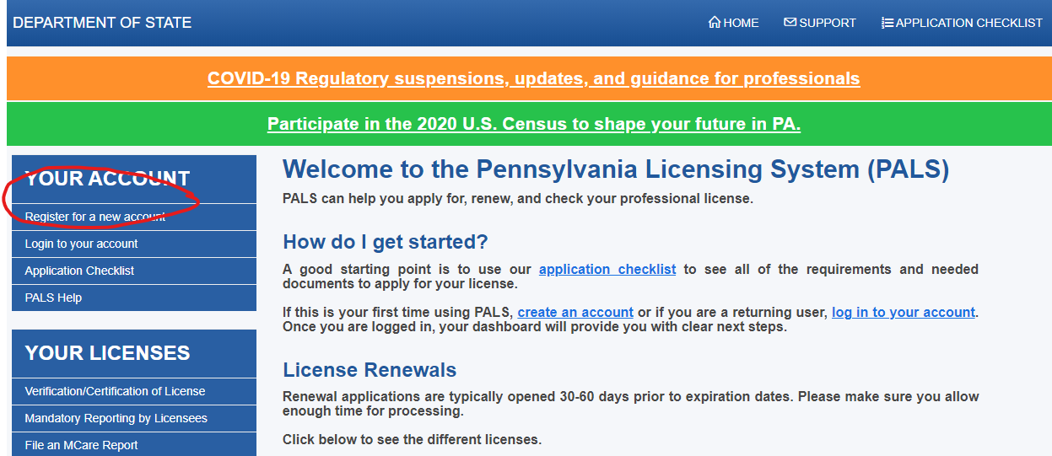

2. If you ALREADY have a PALS account from you must complete the following steps:
- Print the State Registration document. The document is not virtual so you must print it out or have the therapist print it out first, sign it and either email a PDF to you or mail it to you.
- Have EACH SLP with whom you work sign a form to indicate that they are working with/supervising you. You do not need to indicate how many days a week you are working with them.
  - If you are working with 3 therapists- you need to have 3 signed documents
- Scan the documents so that you have a PDF attachment then email those documents to: st-speech@pa.gov
  - Indicate that you would like to attach the forms to your PALS account linking you to those therapists.
3. If you are registering for a NEW PALS account:
- Locate the digital form under your account
- Download and have EACH SLP sign the form
- Upload each form to your PALS account

4. If you are attached to the license of a therapist with whom you NO longer work:
- Email the state board to request that they be removed from your account.
st-speech@pa.gov

5. All supervision forms should be completed and sent the PA speech board within 30 days of hire.
FOR COOPERATING SLPs

- If you are working with an SLPA you MUST complete a supervision form in cooperation with the SLPA with whom you are working
- ALL SLP’s are required to report to the state board when they have an SLPA working with them under their license as the supervisor on site.
- Please note that all SLPAs who are hired by an organization in Pennsylvania must possess a bachelor’s degree in some area of communication disorders and have, therefore, already met the requirements outlined as mandatory on the form.
- All SLPAs ARE required to obtain 20 hours of continuing education training as are classroom aides, PCA’s and other support personnel working in Pennsylvania.
- Training hours are captured through a variety of opportunities would include:
- Direct collaboration and training you provide as you model, instruct and support them in therapy techniques.
- Direct instruction/therapy with the students on your caseload.
- Mandatory trainings provided by the hiring agency.
- Trainings and conferences attended by the SLPA.

*The SLP does not need to track these hours.

