

INSTRUCTIONS FOR POSTER PRESENTERS

DISPLAY
- Posters will be displayed on individual easels (see image below)
- Each poster will be provided: an easel, a 36x48 cardboard mounting board, and binder clips or tape.

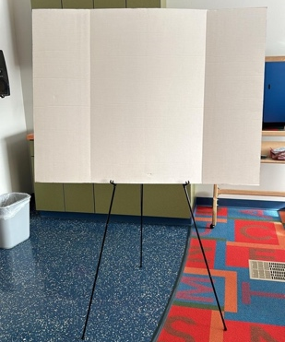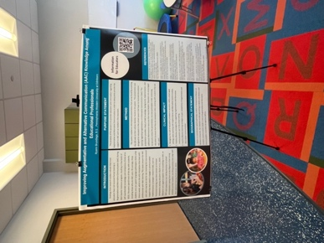

The mounting board is a 36 x 48 trifold, taped flat.
Posters will be adhered using binder clips or tape.

SIZE
- The easels can accommodate posters up to 36” height x 48” width
  - If posters are smaller than 36x48, the presenter will need to tape their poster on the provided mounting board or bring a mounting board cut to desired size

SETUP/TAKE DOWN
- Please see your confirmation email for your scheduled day. There will be a total of about 25 posters each day
- The poster hall will be in the Salon room
- Set up: the morning of the presentation, starting at 8am.
- Take down: the afternoon of the presentation, no later than 4pm
  - Please leave the easel, mounting board, and binder clips in the Salon room

The poster easels and boards are provided by:
Communication Sciences & Disorders Department at Pennsylvania Western University

